System Analysis and Design Interview Topics for Freshers

System Analysis is the "what" before the "how" in system design. It provides the essential roadmap for crafting a system that is both effective and efficient in solving the intended problem. "Imagine you're building a dream house. You wouldn't start hammering nails without a detailed blueprint, right?"The same goes for software development."
System analysis is the blueprint, while system design translates it into the actual system.

1. Information System(IS)
Information systems are integral to system design, shaping the architecture, data management, user interaction, and development process.
By carefully considering the role of IS, system designers can create systems that are robust, user-friendly, and meet the needs of their intended users.

Six Major Components of Information System:
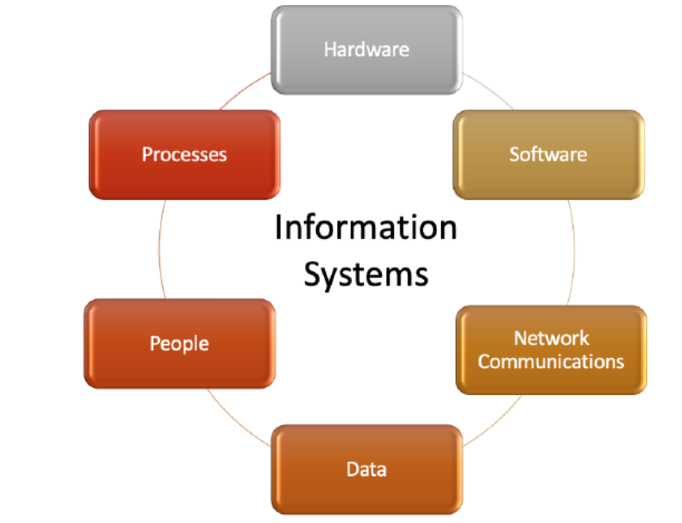

2. Characteristics(Properties) of a System Analysis
Properties of a system analysis are:
- Organization - Arrangement of components.
- Interaction - Procedure in which each component functions with other components.
- Interdependence - Dependence of one component on another component.
- Integration - Refers to how a system is tied together.
- Central Objective - The objective for the system to achieve.

3. Classification of System Analysis
Classification of system analysis is as follows:
- Formal System - Planned or Documented procedures. For example - Scheduled meetings.
- Informal System - Not described by Procedures. For example - Sales orders procession system through telephone call
- Physical System - Tangible entities that may be static or dynamic. For example - Computer.
- Abstract System - Conceptual Entities. For Example - Company.
- Open System - Receives input and provides output to the environment. For example - Organisation.
- Closed System - Isolated from environmental influences. it is rare in reality
- Manual System- Require human intervention. For Example - The railway ticket counter
- Automated System - Does not Require human intervention. For example - Traffic control system
Real Time Systems - Interactive processing system with severe time limitations. There are two types of Real Time systems. They are:
- Hard Real Time Systems complete critical tasks on time. For example - Radar System
- Soft Real Time Systems are the less restrictive type of real time systems. For example - Industrial Control System
System Users - The people who use information systems.
- Internal Users - Employees of the business
- External Users - Customer of the business

4. Distributed Systems
Distributed Systems: Data, Process and Interface components are distributed to multiple locations in computer networks.

Advantages of Distributed Systems:
- Resource Sharing - Allows multiple computers to share resources such as files, printers, and processing power.
- Computation Speedup - Faster execution of tasks as computations are carried out simultaneously.
- Reliability - If one component or node fails, the system can continue functioning using alternative resources.
- Communication - Facilitate efficient communication between nodes, allowing them to exchange information seamlessly.

The five layers of Distributed System architecture are:
- Presentation Layer is the actual user interface and helps in input & output operations.
- Presentation Logic layer include processing for establishing user interface.
- Application Logic Layer includes all the logic and processing for support the application
- Data Manipulation Layer Includes all the commands and logic for storing and retrieving data.
- Data Layer is actual stored data in the database

5. System Analysis and Design
- System Analysis - This involves studying the requirements of either the existing system or a new system in order to design an effective system.
- System Design - Involves the process of creating a well-structured system with careful consideration of objectives and requirements.

Approaches to Development
Attempts to make system development less of an art and more of a science usually referred to as engineering techniques, are applied to system development. Techniques are:
- Prototyping - Designing and building a scaled-down but fundamental version of a desired system is known as prototyping.
- Joint Application Design(JAD) - Users, managers, and system developers are brought together for a series of intensive structured meetings run by a JAD session leader.
- Participatory Design(PD) - Each user has an equal share in determining system requirements and in approving system design

6. System Analyst
A System Analyst is an individual responsible for analyzing requirements and designing information systems.

Role of a System Analyst
- Change Agent - Introduce changes to the user organization.
- Investigator and Monitor - Investigate the existing system to find the reasons for its failure and also monitor programs about time, cost and quality.
- Architect - Creates a detailed physical design of candidate systems.
- Psychologist - Interprets user thoughts, and assesses their behaviour to find facts about the system.
- Motivator - Effective user training and proper motivation to use the system.
- Intermediary - Diplomacy in dealing with people for acceptance of the system.

Duties of a System Analyst
- Defining Requirements -Understand the user's requirements.
- Prioritising Requirements by Consensus - Meeting with all other users and arriving at a consensus.
- Analysis - Analyses the working of the current system
- Solving Problems - Identify alternative solutions and select the best solution for a particular problem.
- Drawing up Functional Specifications - Precise and detailed specifications so it can be used by system implementers.
- Designing Systems - After specifications are accepted, the analyst designs the system
- Evaluating System - Evaluate a system after it has been in use for a reasonable time.

Qualifications of a System Analyst
- Analytical Skills - Includes system study, organizational knowledge, problem identification, problem analysis and problem solving.
- Technical Skills - Includes knowledge of Programming languages, OS, DBMS, different type of computer
- Management Skills - Includes resource management, project management, risk management, change management
- Interpersonal Skills - Includes communication skills, working alone as well as in a team, facilitating groups, and managing expectations.

7. System Development Life Cycle(SDLC)
SDLC, or Software Development Life Cycle, is a common set of steps for system development used by many organizations.

SDLC consists of mainly seven steps or phases. These are:
- Project Identification and Selection - Identifying the need for a new or improved system and selecting priorities for the system.
- Project Initiation and Planning - Detailed work plan, specification of system scope and high-level system requirements.
- Analysis - Includes study of requirements and feasibility.
- Logical Design - it is not tied to any specific hardware and system software platform.
- Physical Design - Turning logical design into technical specifications.
- Implementation - Includes coding, testing and installation.
- Maintenance - Making changes that users ask for and modifying the system to reflect and support changing business conditions.

8. Documentation of Systems
Documentation - It is the process of communicating about the system.

The steps involved in the process of documentation are:
- Collection of source material for documentation
- Documentation Plan
- Review of Plan
- Creation of Document
- Testing of Document
- Maintain Document

9. System Requirements Specification(SRS)
it is a set of complete and precisely stated properties along with the constraints of the system that the software must satisfy.

Characacteristics of a SRS
- Unambiguous - Every requirement stated has only one interpretation.
- Complete - It should include all functions and constraints intended by the system user.
- Realistic & Achievable - The requirements should be realistic and achievable with current technology.
- Verifiable & Consistent - No requirement should conflict with any other requirement.
- Modifiable - Any necessary changes to requirements can be made easily.
- Traceable - The origin of each requirement must be clear.
- Useful - The SRS must address the needs of the operation and maintenance phase.

Structure or Outine of a SRS Document:
- Introduction - Includes its purpose, scope, and objectives.
- Informative description about the system - Includes Information flow representation, Description of sub-systems and System Interface, and the problems it aims to solve.
- Functional Description of the system -Includes Restrictions, limitations, Performance, Design constraints, and software diagram.
- Test and validation criteria - Includes Performance limitations, and expected software response.
- Glossary - Definition of all technical or software-specific terms used in the document.
- Bibliography - Reference of all documents related to the software.

System Design Specification or Software Design Specification
it gives a complete understanding of the details of each component of the system, and its associated algorithms, etc.

10. Fact Finding Techniques or Information Gathering Techniques
Techniques used for collecting data related to the existing system to learn the function of the existing system. Various fact-finding techniques are:
- Interview - This important fact-finding technique, where the system analysts gather information from individuals through face-to-face interaction.
- Group Discussions - A group of staff members are invited by system analysts from different wings for discussion.
- Site Visits - The system analysts visit sites to get information on the working of the system.
- Presentations - The customer makes a presentation of the existing system or about the organisation.
- Questionnaires - Special purpose documents that allow the analyst to collect information and opinions.

Interviews
The steps involved in the interview are Introduction, Asking Questions, Recording the interview, and Doing a final check. There are two types of interviews:
- Structured - There is a specific set of questions to be asked to an interviewee.
- Unstructured - No specific set of questions only a general goal or subject in mind.

Advantages of Interviews
- Get individual's views
- Better clarity of the problem
- The interviewee responds freely and openly

Disadvantages of Interviews
- Very time consuming
- Depends on the system analyst's interpersonal skills
- May be impractical due to the location

Feasibility Study
Consists of activities which determine the existence of the scope of developing an information system for the organisation. There are different feasibility study like
- Technical Feasibility - Concerned with hardware, software and expertise required for the development of the system.
- Operational Feasibility - All about problems that may arise during operations like useful information, response time, Accuracy, Security, and Efficiency.
- Economical Feasibility - Judging whether the possible benefits of solving the problem is worthwhile or not.
- Legal Feasibility - Consideration of copyright law, labour law, antitrust legislation, regulation, etc.

Cost Benefit Analysis
It involves analysing the costs associated with implementing and operating a system against the expected benefits it will bring. Different costs are
- Cost of human resources - Salaries of system analysts, software engineers, programmers, data entry operators, and clerical staff.
- Cost of Infrastructure - Includes computers, cables, software, etc.
- Cost of training - The developing and operating staff need to be trained for new technologies and systems.

11. Modular and Structured Design
Design - it bridges the gap between specifications and coding. Some of the properties of design are Verifiability, Traceability, Completeness, Consistency, Efficiency, and Simplicity.

Design Principles
These principles are meant to effectively handle the complexity of design.
These principles are:
- Problem Partitioning - The system is divided into modules that are self-dependent.
- Abstraction - Designing the outer view of the component without worrying about the details of implementation.
- Top Down Design - Decomposing major components into their subordinate level components and interacting until the desired level of detail is achieved.
- Bottom-Up Design - Process of combining modules to provide larger ones, to compile these to provide event larger ones and so till we arrive at one big module. This approach is more suitable as it starts from some existing modules.
- Structure Chart - it depicts the division of a system into programs along with their internal structure.
- Modularity - it means decomposing a system into smaller components (modules) that can be coded separately.

Guidelines for good design are:
- Factoring - A system should be divided into as many relatively independent modules as possible.
- A superordinate module should control not more than seven subordinates.
- Coupling - The dependency levels between modules should be minimal.
- Cohesion - A module should not perform more than one function.

Coupling
The communication between modules should be through parameters. Boolean variables or flags can be used for communication. There are five types of coupling:
- Data Coupling: Data is passed through parameters for communication.
- Stamp Coupling: Data structure is passed through parameters for communication.
- Control Coupling: Control information is passed through parameters for communication.
- Common Coupling: Global data areas used by the multiple modules.
- Content Coupling: One module can access the data inside another module and alter it. The same goes for the code of the moduls.

Cohesion
A module conforms itself to the performance of a single task.
There are seven types of cohesion. They are:
- Functional Cohesion: If every instruction in the module is related to a single task.
- Sequential Cohesio: All instructions in the module are related to each other the data that is passed to the module and sequence of the instruction matters.
- Communicational Cohesion: All instructions in the module are related to each other the data that is passed to the module and the sequence of the instruction doesn’t matter.
- Procedural Cohesion: Instructions are related to each other by the control flow.
- Temporal Cohesion: All instructions are related to each other by only the flow of control and are unrelated to their sequence.
- Logical Cohesion: The relation between instructions in the module is zero or bare minimum.
- Coincidental Cohesion: There is no relationship between instructions in the module.

12. Form Design
Forms are used for collecting data from users. Form design refers to the process of creating intuitive and user-friendly forms.
The common GUI controls used in forms for inputs include:
- Text Box:Allows for single or multiple lines of characters.
- Radio Button: Helps quickly identify and select a particular value.
- Check Box: Provides an option for the Yes/On value.
- List Box: Requires the selection of a data item’s value from a list of possible choices.
- Dropdown List: Suggests the existence of a hidden list of possible values.
- Combination Box: Combines the capabilities of a text box and a list box.
- Spin Box: Allows the user to make an input selection using navigation buttons.

Criteria for form design
To create a well-conceived and attractive design form, we have to satisfy the following criteria:
- Organisation: Logical arrangement of form elements, Clear and intuitive information structure.
- Consistency: Uniformity in design elements, Standardized layout, fonts, and colours.
- Completeness: Inclusion of all necessary fields, Avoidance of unnecessary or redundant questions.
- Flexible Entry: Accommodation of various input formats, Clear instructions and validation for user guidance.
- Economy: Concise form with essential elements, Balanced information collection for user convenience.

13. Report Design
Reports are used for presenting and summarizing data in a structured format. Report design refers to the process of creating clear, organized, and user-friendly layouts for displaying information.

Types of Output for Report Design
- Internal Outputs - Intended for the owners of the system and the user within the organization. Examples: Detailed Reports, Summary Reports, etc.
- External Outputs - Intended for customers, suppliers, partners and regulatory agencies. Examples: Invoices, Account statements, paycheques, telephone bills, etc.

Criteria for report design
For producing a good report following criteria should be considered:
- Relevance: Focuses on information essential to the report's goals.
- Accuracy: Ensures that data and facts are reliable and error-free.
- Clarity: Uses clear language, concise formatting, and visual aids for effective communication.
- Timeliness: Ensures that the information remains current and applicable.
- Cost: Balances the quality of the report with the associated costs.

User Interface Design
it involves creating interfaces that facilitate effective communication between users and computer systems. It focuses on making interactions intuitive, efficient, and user-friendly.
If you are interested to learn more about design, you can refer Design Pattern Tutorial.

14. Process Modeling or Data Flow Diagram (DFD)
Graphical representation of the function and process, which capture, manipulate, store and distribute data between components within a system.

The components of a Data Flow Diagram(DFD) are:
- Entities or Source or Sink of Data: Include the source and destination of the data.
- Process: The tasks performed on the data are known as processes.
- Data Storage: Data storage includes the database of the system.
- Data Flow: The movement of data in the system is known as data flow.

here are the notations for the components:
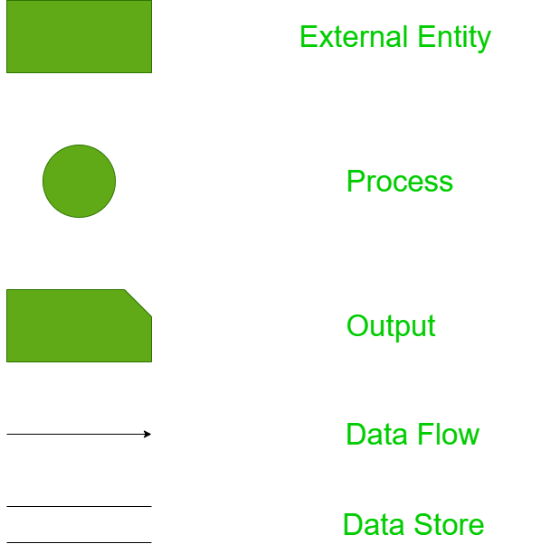

15. CASE Tools – Computer-Aided Software Engineering Tools
All software that supports managerial, technical, or administrative aspects of any part of the software development process is termed as CASE tools.

Use of CASE Tools:
- Facilitating Single Design Methodology: Aiding in the standardization of the development process.
- Rapid Application Development: Improving the speed and quality of system development.
- Testing: Enhancing the testing process through automated checking.
- Documentation: Improving the quality and uniformity of documentation.
- Project Management: Automating various activities involved in project management.
- Productivity and Cost Reduction: Automating various activities in system development and increasing the productivity of the development team.

Role of CASE Tools:
- Project Management
- Data Dictionary
- Code Generation
- User Interface Design
- Schema Generation
- Creation of Metadata for Data Warehouse
- Reverse Engineering
- Re-engineering
- Document Generation
- Version Control
- Object-Oriented Analysis and Design
- Software Testing
- Data Modeling
- Project Scheduling
- Cost Estimation

Advantages of CASE Tools:
- Integrated Development Environment
- Guidance in Development
- Consistency Between the Model and Documentation

Types or Components of CASE Tools:
- Planning and Management Tools
- Analysis Tools
- Design Toolset
- Information Integrator
- Code Generator
- Database Design Toolset
- User Interface Generator
- Report Generator
- Rational Rose: One of the most widely used CASE tools in the software community.
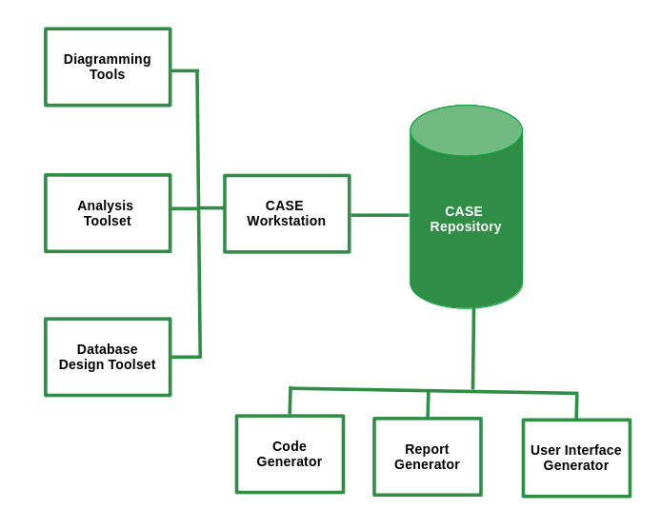
- UML modeling: The Unified Modeling Language is primarily a graphical modeling language used to express designs.
- Emerging CASE tools: Integrated CASE (I-CASE).
- Object-Oriented CASE tools: Paradigm Plus from Protosoft, Rational Rose from Rational, and WithClass

16. Implementation of Systems
It involves coding, testing, creating necessary hardware, and providing training to end-users.

System Testing
A holistic approach to testing the application. Types include Recovery Testing, Security Testing, Stress Testing, Performance Testing, Response Testing, Usability and Documentation Testing.
- Alpha Testing: Carried out by the customer at the developer site in a controlled environment.
- Beta Testing: Carried out at one or more customer sites by end-users.

Converting Old System to the New System:
Can be performed in several ways depending on system criticality and related issues:
- Direct Conversion: Old system is shut down, and the new system starts.
- Pilot Conversion: New system is installed at a single pre-decided location.
- Parallel Conversion: Old system runs alongside the new system until management and users are satisfied.
- Phased Conversion: Different sub-systems of the new system are used in conjunction until the whole new system is converted.

17. Maintenance of Systems
Monitoring, evaluating, and modifying the information system to make necessary desirable changes. Maintenance activity has four key stages:
- Help Desk: Initial stage for users to report issues or seek assistance.
- Analysis: In-depth examination of reported issues and system performance.
- Implementation: Incorporation of enhancements based on analysis findings.
- Release: Deployment of the modified information system to users.

Different Maintenance Activities
- Corrective Maintenance: Rectifying design, coding, and implementation problems detected after system implementation.
- Adaptive Maintenance: Changes in the operation system, hardware, or DBMS.
- Perfective Maintenance: Adding new functionalities and features to the software.
- Preventive Maintenance: Changes made to software to make it easily maintainable and prevent system failure in the future.
Legacy System: A very old and large system modified heavily since its inception. Solutions include replacing software with a package, re-implementing from scratch, discarding software, freezing maintenance and phasing in a new system, or reverse engineering the legacy system.

18. Audit of Computer Systems
An assessment of an information system to provide recommendations and advice to improve system performance and security. It is done by an IS auditor. Objectives of the audit are:
- To improve the quality of the information system.
- Prevent failure.
- Speed up the process.
- Improve cost performance.
- Increase efficiency.
- Reduce risk and enhance system security.
- Standardization.

Responsibility and Authority of the System Auditor:
- Should firmly maintain professional ethics.
- Should be aware of the ethical demands on themselves.
- Should meet internal and external trust by performing an accurate and sincere system audit.
- Must maintain confidentiality of the information provided to them.
- May demand data and material from the division being audited.
- May also demand a report on the implementation of improvements to an audit division as suggested by them.

Factors Audited by IS Auditor:
- Audit of response time: Actual response time compared with the desired response time.
- Audit of broken links: Findings of broken or unavailable links on the website.
- Database Audit: Checking the database integrity and availability.
- Network Audit: Checking the vulnerability and configuration of the network.
- Transaction Audit: Process to find who made changes, what changes were made, and whether the changes were authorized.
- Audit of Computer Security: Reviewing physical and logical security measures.
- Audit of Application: Assessment of manual and programmed internal controls of the information system.

Some Important Terms
- Visual Audit Pro - A software that audits activities like logging on/off, and collects information about software and hardware.
- E-Z Audit -A software that gives information on RAM capacity, network card name, network connect speed, MAC address and TCP/IP information.
- IDEA(Interactive Data Extraction and Analysis) - Used to import information from the database to be audited for further analysis by the auditor.
- Audit Trail - A log of changes made in data, settings and related changes.
Risk Assessment - Evaluating threats and vulnerabilities of IS. two methods are there for analysing the risks:
- Quantitative Risk Analysis - Gives an idea about the amount of risks involved with an event.
- Qualitative Risk Analysis - Gives the degree of risk associated with the institution’s system, networks and information assets.

Disaster Recovery Plan
- Disaster - Earthquakes, floods, fires and terrorist attacks can severely damage an organisation's computing infrastructure.
- Disaster Recovery Plan - A document containing procedures for emergency response, extended backup operations and recovery.

Techniques applied for contingency situations are:
- In-house backup - The process of storing data backups within the organization
- Alternate Storage Area - Store one copy of all AIS files and databases at an alternative site.
- The Disaster Recovery Toolkit - A highly valuable collection of items and documents for ensuring business continuity in disaster.
Contigency Events | Necessary Recovery Action
Loss of Data | Identify the appropriate recovery plan, The location of required recovery files.
Loss of Software | Identify the type of software and location where backup copies are maintained.
Loss of Communication | Identify alternate communication facility, Estimate recovery time.
Loss of hardware | Identify any alternate substitute for the equipment. Estimate replacement cost of hardware.
Loss of Personnel | Identify substitutes for each personnel, if alternates are not available then obtain them from an outside source.
Loss of Facility | Identify all necessary hardware, software, data, and personnel required for normal functioning at the alternative location

Contingency Planning Steps:
- Develop the plan.
- Test the plan.
- Maintain the plan.

19. Viruses
One of the biggest security threats to computer systems can cause irreparable damage to certain systems. Anti-virus measures for protecting against viruses include:
- Make a backup of all data.
- Use anti-virus software.
- Open email attachments with caution.
- Regularly update software.
- Stay updated about the latest security news.

20. Concurrent Audit
Data is audited while the transaction is in progress. It helps in finding missing audit trails and is also used in monitoring largely integrated and automated systems.

Concurrent Audit Techniques
- Integrated Test Facility (ITF) Technique : Auditing software is embedded into the client software.
- The Snapshot Technique: Embedded auditing software takes a snapshot before and after the process of critical processing.
- System Control Audit Review File (SCARF): Embedded auditing software monitors the system transaction uninterruptedly and stores the collected information in a SCARF master file.
- Continuous and Intermittent Simulation techniques (CIS): Used DBMS to trap exceptions.

21. Different Kinds of Information Systems

Management Information System (MIS)
It helps the organization produce information that can aid in improving decision-making, problem-solving, controlling operations, and creating new products or services.Generates semi-structured, ad-hoc reports tailored for strategic management. Examples: Marketing information systems.

Transaction Processing System (TPS)
TPS processes data from business operations, providing essential support for day-to-day operations. Handles routine transactions, employs fixed periodic reporting, and serves operational management needs. Examples: Sales processing systems, and online reservation systems.

Decision Support System (DSS)
DSS utilizes analytical models, specialized databases, and internal data to provide interactive decision support. Offers reports like sensitivity and what-if analyses, catering to individual manager's decision-making needs. Example: Geographic Information System (e.g., IBM's Geo-Manager).

Expert System
Expert Systems apply knowledge from a specific field, delivering expert advice within a defined domain. Provides human-like expert advice; sought by managers seeking specialized knowledge. Example: Medical diagnostic expert systems (e.g., MYCIN).

System Design Interview Questions and Answers [2025]
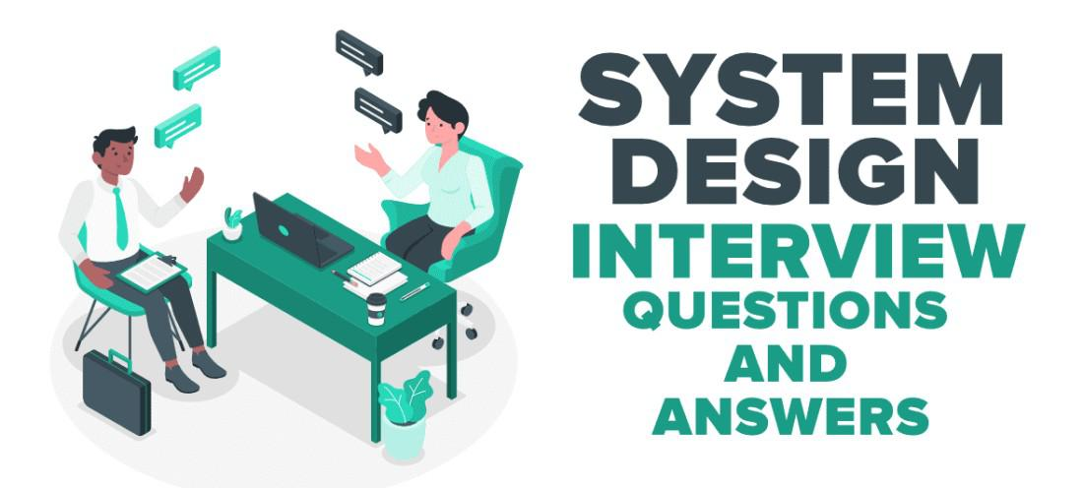

1. Design a URL Shortening Service (TinyURL)
URL shortening service allows users to enter a long URL, and then it returns a shorter, unique URL. These services generate a short URL if the user gives a long URL and if the user gives a short URL then it returns the original long URL.

Things to discuss and analyze:
- Given a long URL, the service should generate a shorter and unique alias for it.
- When the user hits a short link, the service should redirect to the original link.
- Consider scalability if 1000's URL shortening requests come every second.
- Service handle redirects.
- Support for custom short URLs.
- Track click stats.
- Delete expired URLs.
- The system should be highly available.
You need to consider three things while designing this service.
- API(REST API) - Discuss how the client will follow an approach to communicate with the service along with the load balancer which is the front end of the service.
- Application Layer - Discuss how the worker thread or hosts that will take the long URL, generate the tiny URL and how it will store both of the URLs in the database.
- Persistence Layer - Database

2. Design YouTube/Netflix (A Global Live Video Streaming Service)
Design a video streaming service like Youtube/Netflix where users can upload/view/search videos. The service should be scalable where a large number of users can watch and share the videos simultaneously. It will be storing and transmitting petabytes and petabytes of data.

Things to discuss and analyze:
- Approach to record stats about videos e.g. the total number of views, up-votes/down-votes, etc.
- Adding comments on videos in real-time.

3. Design Facebook Messenger or WhatsApp (A Global Chat Service)
To design a global chat service like Facebook Messenger or WhatsApp, you need to focus on real-time communication, scalability, and reliability. Start with user management for registration and login, then implement messaging using technologies like WebSockets for real-time data transfer. For message storage, use distributed databases to handle large amounts of data across different regions. Ensure reliability with features like delivery receipts and read acknowledgments.

Things to discuss and analyze:
- Approach for one-on-one text messaging between users.
- Approach for extending the design to support group chats.
- Delivered and read status
- What action needs to be taken if the user is not connected to the internet?
- Push notifications
- Sending media like images or other documents
- Approach for providing end-to-end message encryption.

4. Design Quora/Reddit/HackerNews (A Social Network + Message Board Service)
These services allow users to post questions, share links and answer the questions of other users. Users can also comment on questions or shared links.

Things to discuss and analyze:
- Approach to record stats of each answer such as the number of views, up-votes/down-votes, etc.
- Follow options should be there for users to follow other users or topics.
- News feed generation which means users can see the list of top questions from all the users and topics they follow on their timeline.

5. Design Search Typeahead (Autocomplete)
Typeahead service allows users to type some query and based on that it suggests top searched items starting with whatever the user has typed.

Things to discuss and analyze:
- Approach to storing previous search queries
- Real-time requirement of the system
- Approach to keep the data fresh.
- Approach to find the best matches to the already typed string
- Queries per second are to be handled by the system.
- Criteria for choosing the suggestions.
- A total number of data to be stored.
- Approach to find the best matches to the already typed string

6. Design Dropbox/Google Drive/Google Photos (A Global File Storage and Sharing Service)
Design a file or image hosting service that allows users to upload, store, share, delete, and download files or images on their servers and provides synchronization across various devices.

Things to discuss and analyze:
- Approach to upload/view/search/share/download files or photos from any device.
- Service should support automatic synchronization between devices, i.e., after updating a file on one device, it should get synchronized on all devices.
- ACID (Atomicity, Consistency, Isolation, and Durability) properties should be present in the system.
- Approach to track permission for file sharing.
- Allowing multiple users to edit the same document.
- The system should support storing large files up to a GB.

7. Design a Web Crawler
Design a Web Crawler scalable service that collects information (crawls) from the entire web and fetches hundreds of millions of web documents.

Things to discuss and analyze:
- Approach to finding new web pages.
- Approach to prioritize web pages that change dynamically.
- Ensure that the crawler is not unbounded on the same domain.

8. Design Facebook, Twitter, or Instagram.
You need to design a social media service for billions of users. Most of the interviewers spend time discussing news feed generation services in these apps.

Features to be considered:
- Some of the specific Twitter/Facebook/Instagram features are to be supported.
- Privacy controls around each tweet or post.
- Users should be able to post tweets also the system should support replies to tweets/grouping tweets by conversations.
- Users should be able to see trending tweets/posts.
- Direct messaging
- Mentions/Tagging.
- The user should be able to follow another user.

Things to analyze:
- The system should be able to handle the huge amount of traffic for billions of users.
- Number of followers
- The number of times the tweet has been favored.

9. Design Uber or Lyft (A Ride-Sharing Service)
Design a service where a user requests a ride from the app, and a driver arrives to take them to their destination. A frequently asked interview question in the system design round of interviews.

Things to analyze and discuss:
- The backend is primarily serving mobile phone traffic. uber app talks to the backend over mobile data.
- How dispatch system works (GPS/ location data is what drives the dispatch system)? How efficiently can the user match request with nearby drivers?
- How do maps and routing work in Uber? How ETAs are calculated?
- An efficient approach to store millions of geographical locations for drivers/riders who are always on the move.
- Approach to handle millions of updates to driver location.
- Dispatch is mostly built using Node.js
- Services: Business logic services are mostly written in Python.
- Databases: Postgres, Redis, MySQL.

10. Design an API Rate Limiter(Github)
Design a service or tool that monitors the number of requests per window of time a service agrees to allow. If the number of requests exceeds the rate limit blocks all the excess calls.

Things to analyze and discuss:
- Limiting the number of requests an entity can send to an API within a time window, for example, twenty requests per second.
- Rate limiting should work for a distributed setup, as the APIs are available through a group of servers.
- How to handle throttling (soft and hard throttling etc.).

11. Design a Notification System (Push Notifications)
Design a Notification System that monitors the number of requests a service receives and blocking excess calls when the limit is exceeded.

Things to analyze and discuss:
- Facilitate real-time user engagement through timely notifications.
- Implement user registration with customizable preferences.
- Define events triggering notifications from external systems.
- Generate dynamic and personalized notification content.
- Integrate with push notification services for cross-platform delivery.
- Optimize delivery through batch processing and user feedback.
- Prioritize secure communication and token management for data protection.
- Implement throttling mechanisms to control notification volume.
- Ensure scalability with horizontal scaling and redundancy.
- Utilize logging and auditing for monitoring, troubleshooting, and performance optimization.

Conclusion
In conclusion, mastering system design interviews requires understanding key principles like scalability, performance, reliability, data management, and security. Practice with common questions on distributed systems, load balancers, databases, caching, and microservices is crucial. Familiarity with trade-offs and best practices, combined with regular practice and feedback, will enhance your performance and confidence in these interviews.

System Analysis Design -Chapter 3 - Information Gathering

Learning Goals
 Strategy to gather information for computerization.
 Various sources of information.
 Methods of searching for information.
 Interviewing techniques to gather information from line managers to top management.
 Methods of consensus for formulating requirements.

Information Gathering Strategies
 Identify Information Sources.
 Evolve a method of obtaining information from the identified sources.
 Use Information flow model of organization.

Information Sources
 Users of System.
 Forms and Documents used in the organization.
 Procedure manuals, rule books etc.
 Reports used by the organization
 Existing computer programs(If Any).
 Interviews are very important.
 Use organization chart.
 Understand the importance of the people who operate the system-Clerks,Line managers.
 Gather information from Middle level persons who have lot of experience
 Gather both qualitative and quantitative information & Observe how the organization works.

Information Gathering Tools
 Review of Literature, Procedures and Forms.
 On Site Observation.
 Interviews and Questionnaires.

Review of Literature, Procedures and Forms
 Who uses the forms?
 How important are they to the user?
 Do the forms include all the necessary information?
 What items should be added or deleted?
 How many departments receive the existing forms? Why?
 How readable and easy to follow in the form?
 How does the information in the form help other users make better decisions?

On Site Observation
 What kind of system is it? What does it do?
 Who runs the system? Who are the important people in it?
 What is the history of the system? How did it get to its present stage of development?
 What kind of system is it in comparison with other systems in the organization?
 Is it a fast paced or slow system to external crises?

Problems in On Site Observation
 Intruding into the user’s area often results in adverse reactions by the staff, therefore adequate preparation and training are important.
 Attitudes and motivations cannot be readily observed.
 Observations are subject to error due to the observer’s misinterpretation.
 Unproductive, long hours are often spent in an attempt to observe specific one time activities or events.

Interviews
 It is a face to face interpersonal role situation, in which a person called the interviewer, asks questions to another person, designed to gather information about a problem.
 Advantages of Interview:
 It is a superior technique used for exploring areas.
 It offers better opportunity to evaluate the validity of the information gathered.
 The interviewer can observe not only what they say and how they say.
 It is an effective technique for eliciting information about complex subjects.
 Many people enjoy being interviewed, regardless of the subject. Interviews
 Drawbacks of Interview:
 long preparation time

Planning an Interview
 Make a list of people to be interviewed and in what order
 Plan and note down a list of questions to be asked
 Plan several interviews with same person mainly to clarify doubts
 Interview groups as appropriate

Interviewing Technique
 Make appointment.
 Assign time.
 Read background material.
 State purpose of interview.
 Be punctual and pay attention to what user says.
 Obtain both quantitative and qualitative Information
 Discriminate between essential and appropriate requirements
 State what you understand and get it confirmed
 Do not extend interview
 Summarize information gathered and get it checked by the interviewee

Use of Questionnaires
 Questionnaires useful for statistical data collection
 Useful when large number of persons have to respond
 Make questionnaires short
 Design questionnaires by enumerating objectives and data needed to meet the objectives
 Several follow-ups/personal interviews may be required to get questionnaires back from respondents

Advantages of Questionnaires
 It is economical and requires less skills to administer than the interview.
 A questionnaire can be administered to large number of individuals simultaneously
 Questionnaires ensure uniformity of questions
 In a questionnaire respondents give opinion without fear
 Respondents have time to think the questions over and do calculations to provide more accurate data

Types of Interviews and Questionnaires
 The Unstructured Alternative
 The Structured Alternative

The Unstructured Alternative
 It is a relatively nondirective information gathering technique.
 It allows respondents to answer questions freely in their own words.
 The responses are spontaneous rather than forced.
 System analyst should encourage the respondent to talk freely

The Structured Alternative
 The questions are presented with exactly the same wording and in the same order
 Questions may be either closed or open ended.
 An open ended question requires no response direction or specific response

Closed Questions
 Closed questions are those in which the responses are presented as a set of alternatives.
There are five major varieties:
▪ Fill in the blanks:
▪ Dichotomous (yes/no type) questions:
▪ Ranking scales questions
▪ Multiple choice questions
▪ Rating scales questions

Information Gathering other Methods
 Existing system(If any)
 Systems in similar organization
 Observe workflow in workplace
 Case repository in own organization

